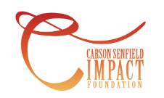

*The Carson Senfield Foundation was developed to make an IMPACT on the lives of young people who embody the character and compassion that Carson had for others. Our desire is to be able to help high school students and youth organizations by offering more opportunities for success through higher education scholarships and grants.*

Carson Senfield graduated from Orchard Park High School in 2021, with a future full of promise and a love for life like no other. In his sophomore year at the University of Tampa, Carson was tragically killed on September 17, 2022- the night of his 19th birthday-but his legacy of love lives on. Carson always found the good in people and sought to be a friend to those who needed love, support, and guidance. Surrounding himself with positive influences everywhere he went, he developed a bright, joyous personality that was infectious to those around him. He was genuinely kind, down to earth, selfless and generous, with the ability to make anyone he met feel special. Carson was the essence of leadership without needing the glory, setting an example for others with just his uplifting spirit and smile.

We will be having our annual golf tournament to benefit the Carson Senfield Foundation. The golf tournament will be held on Monday, June 23, 2025 at Cloverbank Country Club.

Enclosed with this letter is a donation form. We hope you will consider supporting our foundation by donating a gift certificate, hotel stay, tickets, memorabilia items, cash donations, or any other services.

The Carson Senfield Foundation is a 501(c)3 non-profit organization. Any donation you give may be tax deductible. NYS Charity Registry #49-50-53 and Federal Tax ID #92-3201690. This organization will support the spirit of Carson and the meaning of IMPACT.

If you have any questions or would like further information regarding making a donation, please refer to www.carsonsenfieldfoundation.com or contact the Senfield family at cdsen@verizon.net.

Sincerely,

# Daren and Bridget Senfield

Daren & Bridget Senfield cdsen@verizon.net

www.carsonsenfieldfoundation.com

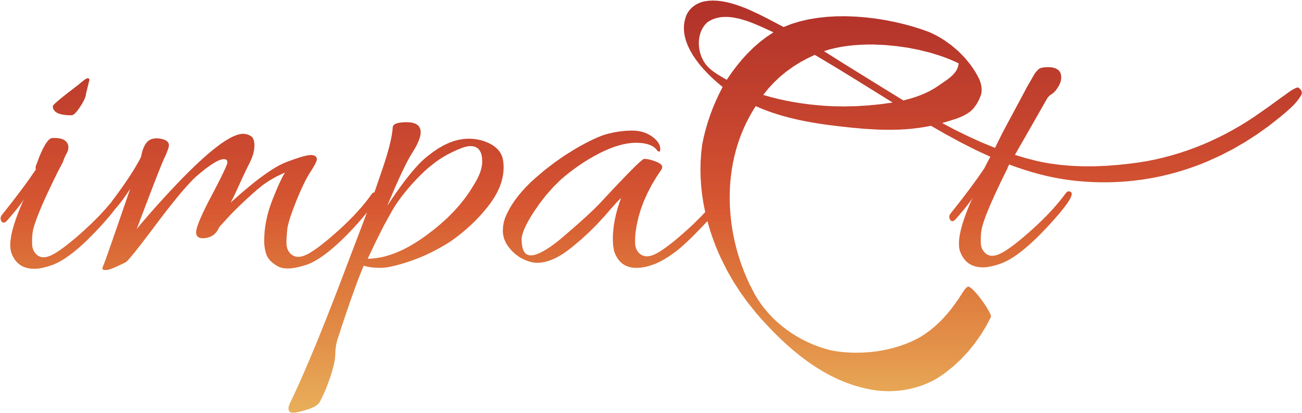

 In-Kind Donation Form

Donor Name: ______________________________________________________________

Contact Person: ____________ Title: _________

Address: __________________________________________________________________

City: _______ State: Zip: _________ Phone: ________________________

Email: ____ ____________________________________________________________

Item Donated: ____________________________________________________________

Value: $______________________

Description: _______________________________________________________________

_________________________________________________________________________ _________________________________________________________________________

***Please Check One:***

* **Certificate/Merchandise Enclosed**
* **Please create gift certificate for us (with specifics from above)**
* **"Experience" package (ie. spa weekend, condo stay, golf trip)**
* **Monetary donation (check made out to The Carson Senfield Foundation)**
* **Please call us to schedule a pick-up**

**Please email or mail form by Monday June 2, 2025 to:**

**Carson Senfield Foundation**

**PO Box 190**

**Orchard Park, NY 14127**

**Email:** [**cdsen@verizon.net**](mailto:cdsen@verizon.net) **or bdsen@verizon.net**

**For questions, please call Nicole Dayka at 716-997-0254**

***Thank you for your support!***

*Carson Senfield Foundation is 501(c)(3) not-for-profit corporation.*

*TERMS: This event does not endorse or promote any product or service of the Sponsor(s) or of any third party. The entire liability of Carson Senfield Foundation, and its sponsors’ exclusive remedy for damages from any cause related to or arising out of the Agreement/Event, will not exceed a refund of actual funds paid to Carson Senfield Foundation by the Sponsor and not yet expended by Carson Senfield Foundation.*

## “Impacting the lives of young people”

--------------------------------------------------------- *For Foundation Use* -------------------------------------------------------------

Date Received: ________________ Tax Receipt Sent: _______________ Solicitor: _______________